Name______Sikha Chaudhary________ Mark _____________________/50

1. Brief introduction __/3
This document outlines the game development process for the collectible system in a combat-based game. In this game, I will be working on a feature called collectables. Players engage in one-on-one matches, and before each fight, they have a limited time to collect various items. These collectibles provide advantages such as health recovery, power-ups, and tactical equipment, influencing the outcome of battles. Some of the things that can be collected are : Blades, Crossbows, healing potions, Adrenaline shots and so on.

2. Use case diagram with scenario __14
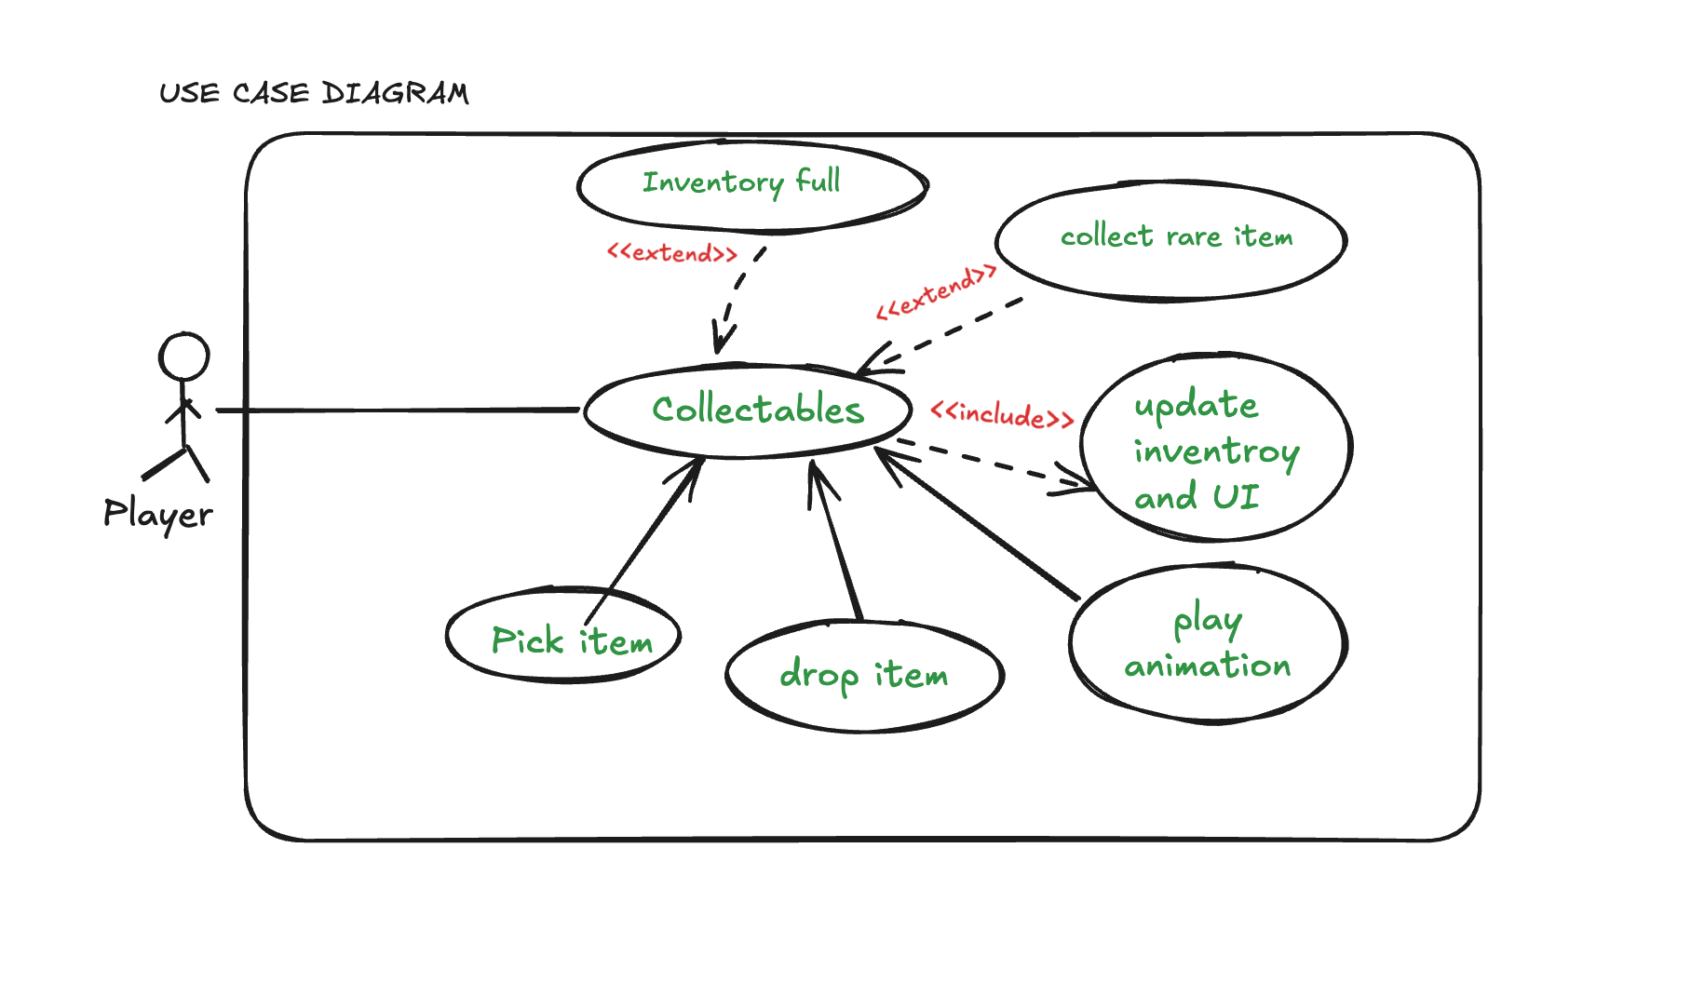

Use Case Diagrams

Scenarios
Use case scenario for Collectables(Collect an item before the game starts).
Name: Collectables
Summary: Players gather collectible items that offer strategic advantages before a fight begins.
Actors: Player
Preconditions: The match has been initialized, and the pre-fight collection phase is active.

Basic sequence:
Step 1: The game enters the pre-fight collection phase.
Step 2:The player moves around the environment to find collectibles.
Step 3: The player picks up an item.
Step 4: The game updates the player's inventory with the collected item.
Step 5 : The phase ends when time expires or the player chooses to proceed to battle.
Exceptions:
Step 1:If inventory is full, the player cannot pick up additional items..
Step 2:If time expires, the player is automatically moved to battle mode.
Post conditions: Picking up an item includes an animation and sound effect for better player feedback and if the player collects a rare item, a special event may trigger.
Priority: 1*
ID: C01
*The priorities are 1 = must have, 2 = essential, 3 = nice to have.

Use case scenario for Pick an item.
Name: Pick an item
Summary: The player collects an item from the environment.
Actors: Player
Preconditions: The player is within range of a collectible item.
Basic sequence:
Step 1: The player moves towards the item.
Step 2:The player interacts with the item to pick it up.
Step 3: The game verifies if the inventory has space.
Step 4: If space is available, the item is added to inventory.
Exceptions:
Step 1:If inventory is full, the player cannot pick up additional items..
Step 2:If time expires, the player is automatically moved to battle mode.
Post conditions: Picking up an item includes an animation and sound effect for better player feedback and if the player collects a rare item, a special event may trigger.
Priority: 1*
ID: C02
*The priorities are 1 = must have, 2 = essential, 3 = nice to have.

Use case scenario for Drop an item.
Name: Drop an Item
Summary: The player drops an item from their inventory to free space.
Actors: Player
Preconditions: The player has at least one item in inventory.
Basic Sequence:
- The player opens the inventory.
- The player selects an item to drop.
- The game removes the item from inventory.
- The item is placed back into the game environment.
- UI updates to reflect the inventory change.
Exceptions:
- Step 1: If the inventory is empty, the player cannot drop an item.
Post Conditions: The item is no longer in inventory and appears back in the game world.
Priority: 1*
ID: C03
*The priorities are 1 = must have, 2 = essential, 3 = nice to have.

Use case scenario for Update Inventory and UI.
Name: Update inventory
Summary: The game updates the player's inventory and reflects those changes in UI after picking up an item.
Actors: Game System
Preconditions: The player has collected an item or dropped an item.
Basic sequence:
Step 1: The game tracks the collected/dropped items by the player.
Step 2: The game system executes the logic.
Step 3: The UI updates to reflect the new item.
Exceptions:
Step 1:If inventory is full, the item is not added.
Post conditions: inventory correctly reflects collected items.
Priority: 1*
ID: C04
*The priorities are 1 = must have, 2 = essential, 3 = nice to have.

Use case scenario for Play Animation
Name: Play Animation
Summary: An animation is played when a player picks up an item.
Actors: Game System.
Preconditions: The player has collected an item or dropped an item.
Basic sequence:
Step 1: The game triggers the pickup animation.
Step 2: A sound effect plays to confirm collection.

Exceptions:
Step 1:Only plays when an item is picked or dropped.
Post conditions: The player sees and hears feedback confirming the pickup.
Priority: 3*
ID: C05
*The priorities are 1 = must have, 2 = essential, 3 = nice to have.

Use case scenario for Collect Rare Item
Name: Collect Rare Item
Summary: A rare item is collected, triggering a special event.
Actors: Player, Game System
Preconditions: The player has collected a rare item.
Basic Sequence:
- The game identifies the item as rare.
- A special animation or effect plays.
- The rare item's power-up is applied.
Exceptions:
Step 1:There will be few rate items to collect.
Post Conditions: The player gains a unique advantage.
Priority: 3*
ID: C06
*The priorities are 1 = must have, 2 = essential, 3 = nice to have.

Use case scenario for Inventory Full
Name: Inventory Full
Summary: The player attempts to collect an item but has no available inventory space.
Actors: Player, Game System
Preconditions: The player's inventory is at capacity.
Basic Sequence:
- The player attempts to collect an item.
- The game checks inventory capacity.
- The game prevents the item from being picked up.
- A message is displayed informing the player.
Post Conditions: The item is not added to inventory.
Priority: 2*
ID: C07
*The priorities are 1 = must have, 2 = essential, 3 = nice to have.

3. Data Flow diagram(s) from Level 0 to process description for your feature _______14

Data Flow Diagrams

Level 0 diagram
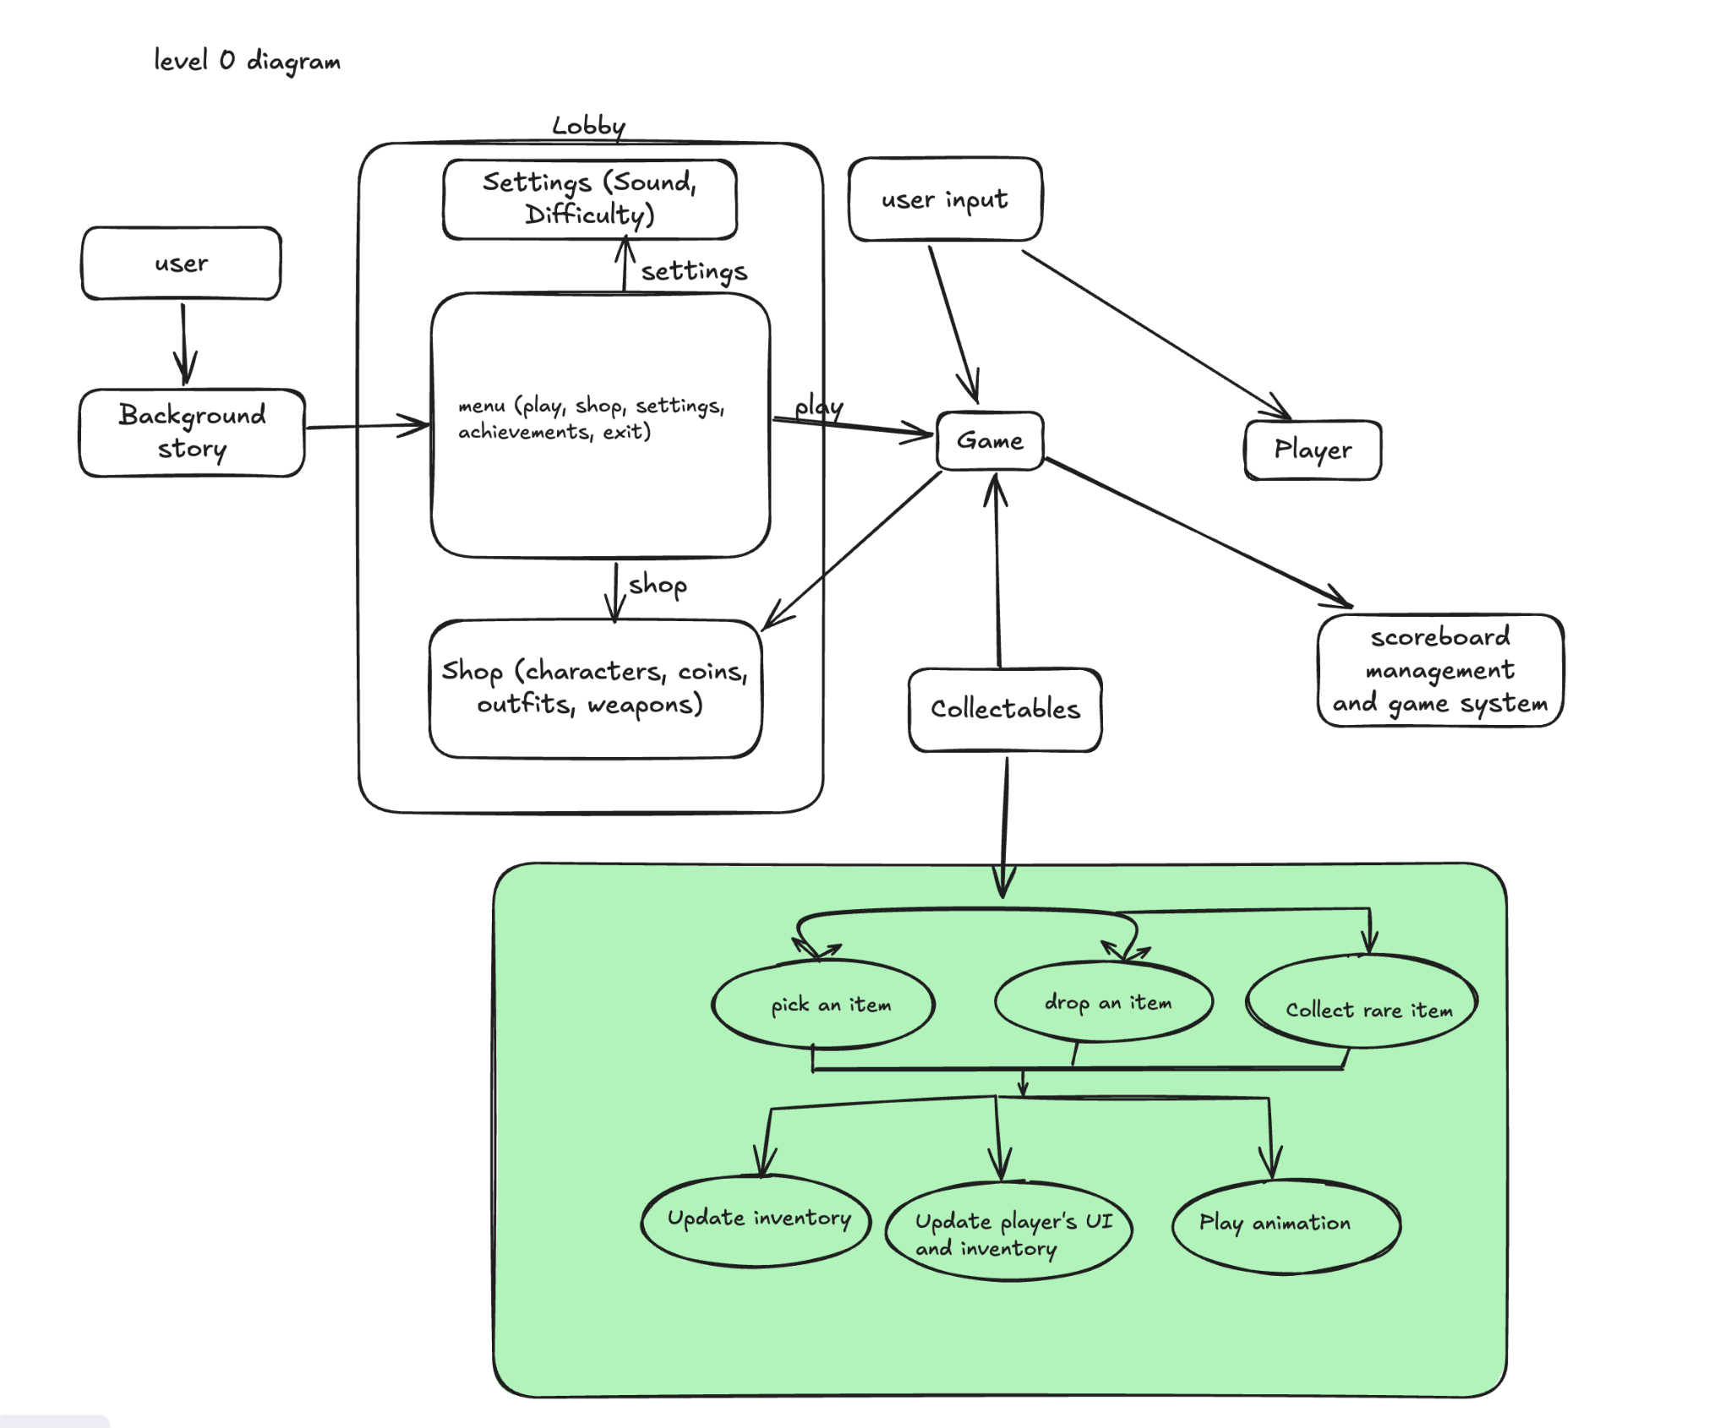

Process Descriptions

1. Start: Pre-fight Phase
This is the phase where players can collect items before the battle.
- Decision 1: Is the pre-fight phase active?
  - Yes : Proceed to Step 2 (Detect player movement).
  - No : End process.
2. Detect Player Movement
The game detects whether the player is near any collectible items.
- Decision 2: Is the player near a collectible?
  - Yes : Proceed to Step 3 (Item Interaction).
  - No : Return to Step 2 (Continue detecting movement).
3. Item Interaction
The player attempts to collect an item.
- Decision 3: Does the player interact with a collectible item?
  - Yes : Proceed to Step 4 (Check Inventory Space).
  - No : Return to Step 2 (Continue detecting movement).
4. Check Inventory Space
The game checks if the player's inventory has space for the item.
- Decision 4: Is there space in the inventory?
  - Yes : Proceed to Step 5 (Add Item to Inventory).
  - No : Exception: Item is not collected. Proceed to Step 6 (Display Inventory Full Message).
5. Add Item to Inventory and Update UI
The item is added to the player’s inventory and updates the UI.
Action : Add item and Update the UI.

4. Acceptance Tests ________9

Test Case 1: Collecting Items Successfully
Steps:
- Start the pre-fight phase.
- Move player near a collectible.
- Player collects the item.
- Check if the item is added to inventory.
- Verify UI updates.
Expected Result:
- Item added to inventory.
- UI reflects the new item.

Test Case 2: Inventory Full
Steps:
- Start the pre-fight phase with a full inventory.
- Move player near a collectible.
- Player tries to collect it.
- Verify the item isn't collected.
- Ensure the "inventory full" message shows.
Expected Result:
- Item not added.
- "Inventory full" message displayed.

Test Case 3: Time Expiry
Steps:
- Start the pre-fight phase.
- Wait for time to expire without collecting items.
- Verify transition to battle mode.
Expected Result:
- Game automatically transitions to battle mode after time expires.

Example for Collecting item feature :
Output | Player Action | Notes | Expected Result
Pre-fight Phase Active | Start the pre-fight phase. | The game transitions into the pre-fight phase where the player can begin collecting items. | Game enters the pre-fight collection phase.
Item in Range | Move player near a collectible. | The player moves towards a collectible item that is within range to be picked up. | Collectible items should be visible and within range of the player for collection.
Collect Item | Player collects the item. | The player interacts with the collectible (e.g., by pressing a button or clicking on the item). | Items are successfully added to the player's inventory.
Inventory Updated | Check if the item is added to inventory. | After collecting, the game should check if there is space in the inventory, then add the item if space is available. | Items appear in the player’s inventory list.
UI Reflects Changes | Verify UI updates to show the collected item | The game's user interface should reflect the new item in the inventory panel, showing the correct item icon, name, or effect. | UI updates with the collected item displayed in the inventory panel.
Confirm Collection | Verify inventory and UI after collection. | Ensure the UI reflects all collected items. If there is a UI for the inventory, it should show the correct number and type of items collected. | The inventory UI shows the newly collected item, confirming the collection process is successful.
Example for Collecting item feature :

Output | Player Action | Notes | Expected Result
Pre-fight Phase Active | Start the pre-fight phase. | The game begins the pre-fight phase with a countdown timer. | Game enters the pre-fight collection phase.
No Collection | Wait for time to expire without collecting items. | The player does not interact with any collectibles and simply waits. | Time runs out as no items are collected.
Time Expired | Verify time runs out without item collection. | The system verifies that the time has expired. | Timer reaches zero and no item collection happens.
Automatic Transition | Game automatically transitions to battle mode. | After time runs out, the game automatically switches to the battle phase. | Game transitions to the battle mode after time expires.

5. Timeline _________/10

Work items
Work Items / Task | Duration (PWks) | Predecessor Task(s)
1. Requirements Collection | 1 | -
2. Collectible Item Design | 2 | 1
3. Inventory System Design | 2 | 1
4. Programming Collectibles | 1 | 2, 3
5. Animation & Sound Effects | 1 | 4
6. Testing | 1 | 5
7. Integration | 1 | 6
8. Final Polish & Debugging | 1 | 7
9. User Documentation | 1 | 8
10. Release Preparation | 1 | 9

Pert diagram
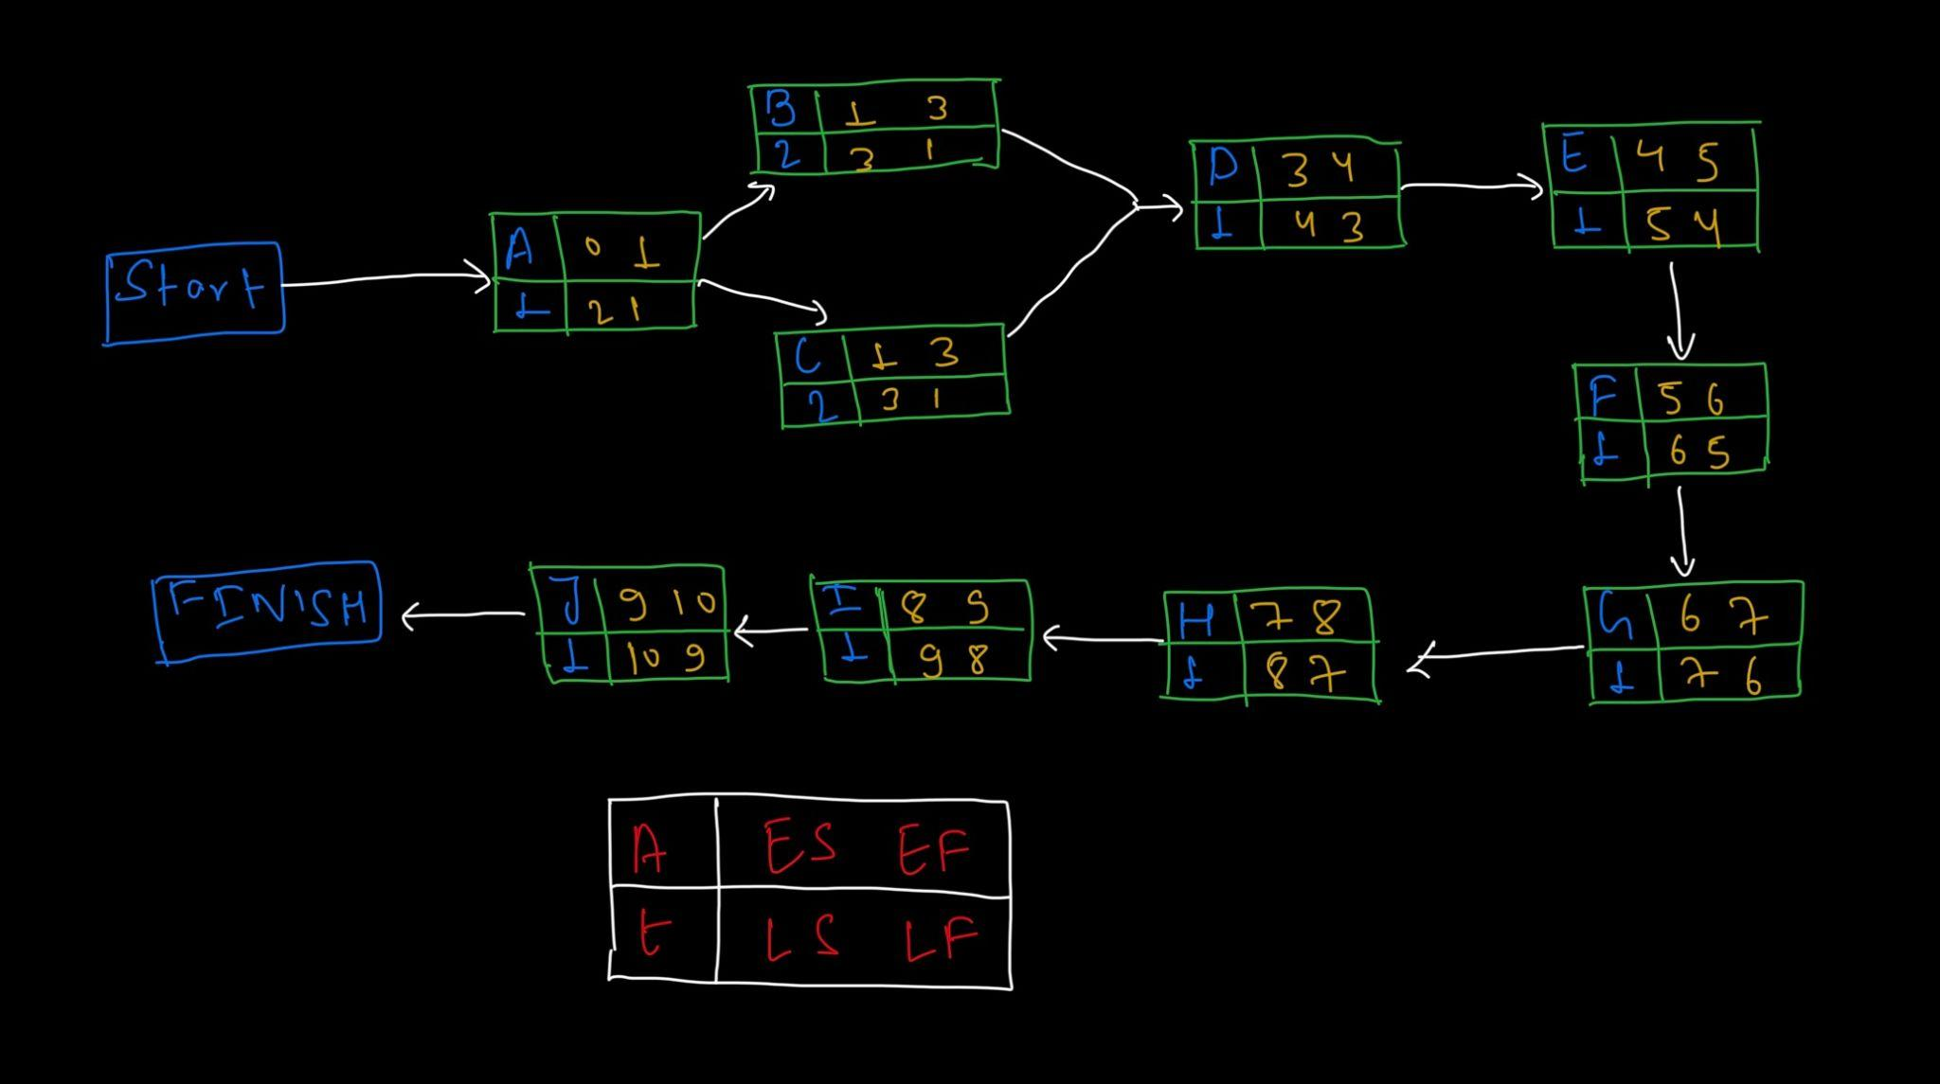

Work Items / Task | Duration (PWks) | Predecessor Task(s)
1. Requirements Collection | 1 | -
2. Collectible Item Design | 2 | 1
3. Inventory System Design | 2 | 1
4. Programming Collectibles | 1 | 2, 3
5. Animation & Sound Effects | 1 | 4
6. Testing | 1 | 5
7. Integration | 1 | 6
8. Final Polish & Debugging | 1 | 7
9. User Documentation | 1 | 8
10. Release Preparation | 1 | 9

Gantt timeline
1 | ✴️1
2 |  |  | 2
3 |  |  |  |  | 3
4 |  |  |  |  |  | 4
5 |  |  |  |  |  |  | 5
6 |  |  |  |  |  |  |  | 6
7 |  |  |  |  |  |  |  |  | 7
8 |  |  |  |  |  |  |  |  |  | 8
9 |  |  |  |  |  |  |  |  |  |  | 9
10 |  |  |  |  |  |  |  |  |  |  |  | 10
 | 1 | 2 | 3 | 4 | 5 | 6 | 7 | 8 | 9 | 10 | 11 | 12 | 13 | 14 | 15 | 16 | 17 | 18 | 19 | 20 | 21 | 22 | 23 | 24

